Feed the Future

Survey Implementation

Document

Anthropometry Manual

Zone of Influence Survey

[COUNTRY] [YEAR]

September 2018

This publication was prepared for review by the United States Agency for International Development. It was prepared by ICF for the United States Agency for International Development, USAID Contract Number GS-23F-8144H/AID-OAA-M-12-00006, Feed the Future PEEL.

**Recommended Citation**

Kiersten B. Johnson and Jasbir Kaur. 2018.

*Feed the Future Zone of Influence Surveys: Anthropometry Manual.*

Washington, DC: Bureau for Food Security, USAID

**Contact Information**

Feed the Future

1300 Pennsylvania Ave, NW

Washington, DC 20004

[www.feedthefuture,gov](http://www.feedthefuture,gov)

Table of Contents

Abbreviations iv

1. Introduction 1

2. Background 1

3. Responsibilities of field teams 3

3.1 Measurers and assistants 3

3.2 Field supervisors 3

4. Anthropometry equipment 4

4.1 The seca 874 U electronic scale 4

4.2 The infant/child/adult ShorrBoard® 5

4.3 Other field materials 5

5. General guidelines and procedures 6

5.1 Where to take the anthropometrical measurements 6

5.2 When to take the anthropometrical measurements 6

5.3 Weigh and measure one person at a time 6

5.4 Position the individual, especially children, with care 7

5.5 Try to minimize stress 7

5.7 What to do if a child has a physical deformity 8

5.8 Practice good hand hygiene 8

5.9 Strive for improvement 8

6. Anthropometry techniques for women 8

6.1 Preparing to take measurements 9

6.2 Measuring a woman’s weight 10

6.3 Measuring a woman’s height 10

6.4 Completing a woman’s measurements and next steps 13

7. Anthropometry techniques for children 13

7.1 Preparing to take measurements 14

7.2 Measuring a child’s weight 15

7.2.1 Children less than 2 years of age 16

7.2.2 Children 2 years of age or older 18

7.3 Measuring a child’s height 18

7.3.1 Children less than 2 years of age 19

7.3.2 Children 2 years of age or older 20

7.4 Completing a child’s measurements and next steps 22

8. Entering the anthropometry information in the tablet 23

9. Reviewing anthropometric results in women ages 15–49 23

10. Practicing taking measurements 24

10.1 Preparing for the practice session 24

10.2 Practice session guidelines 25

10.3 Analyzing the results 25

10.4 Interpreting the results 26

Appendix A: Expected values for height (length) and weight for children ages 0–59 months 28

Appendix B: Scale standardization test 29

Appendix C: Troubleshooting issues with the seca scale 31

Appendix D: Troubleshooting issues while height measurements 32

Appendix E: Anthropometry practice session analysis form 33

Appendix F: Women’s BMI chart 34

List of Figures

Figure 1: Measuring an Adult's Height 11

Figure 2: Measuring a Child’s Length 19

Figure 3: Measuring a Child’s Height 21

List of Tables

Table 1: Growth Failure Descriptions, Indications, Indices, and Comments 2

Table 2: Example of a Boy Age 15 Months Who is 8.0 kg 13

Table 3: Example of Girl Age 36 Months Who is 11.2 kg 13

Table 4: Large, Medium, and Small Differences for Weights and Heights (Lengths) 24

Table 5: Summary of Differences for Weights and Heights (Lengths) for Four Measurers 26

Table B1: Scale Standardization Test Form 29

Table C1: Troubleshooting Errors with the Scale 30

Table D1: Troubleshooting while Taking Height Measurements 31

# Abbreviations

BMI Body mass index

cm centimeter

kg kilogram

UNICEF United Nations Children’s Fund

USAID United States Agency for International Development

ZOI Zone of Influence

# 

# Introduction

Feed the Future seeks to reduce poverty, hunger, and undernutrition among women and children, and to increase income, women’s empowerment, dietary diversity, and appropriate feeding practices. Program efforts are concentrated in Zones of Influence (ZOIs) in Feed the Future target countries. Progress in achieving Feed the Future’s objectives is tracked using population-based performance indicators.

The purpose of the Feed the Future [YEAR] [COUNTRY] ZOI Survey is to provide U.S. Government interagency partners, the United States Agency for International Development (USAID) Bureau for Food Security, USAID/[COUNTRY], the [COUNTRY] government, and development partners with information on the current status of the Feed the Future population-based ZOI-level indicators. The ZOI Survey is designed to monitor progress and determine whether there has been statistically significant change over time at the population level in key outcome and impact indicators, with the expectation that the effects of the program should spread beyond beneficiaries to the general population in the ZOI over the life of the program.

Feed the Future aims to prevent and treat undernutrition by supporting country-owned programs to address its root causes and to accelerate improved nutrition with the goal of reducing stunting of children under 5 years of age. Taking a comprehensive approach, Feed the Future’s nutrition interventions focus on the critical 1,000-day window from pregnancy to a child’s second birthday. The right nutrition during this time can have a profound impact on a child’s health and his or her ability to grow and learn.

# Background

The word ***anthropometry*** comes from two words: anthropo means “human” and metry means “measurement.” Anthropometry is the science of obtaining systematic measurements of the human body.

The Feed the Future ZOI Surveys include common measures of anthropometry, that is, height and weight measurements to assess the nutritional status of respondents and population groups, including children less than 5 years of age and women between 15 and 49 years of age. The z-scores are measured in standard deviations that show how far and in what direction a respondent’s anthropometric measurement deviates from the mean (the reference value). The height and weight measurements, in addition to other information collected during the survey (i.e., age and sex), are used to calculate three nutritional indices that measure growth failure—wasting, stunting, and underweight (Table 1).

Table 1: Growth Failure Descriptions, Indications, Indices, and Comments

|  |  |  |  |
| --- | --- | --- | --- |
| Growth Failure | Description (Indication) | Nutritional Index | Comments |
| Wasting | Acute malnutrition  (extremely thin) | Low  weight-for-height | * Results from recent rapid weight loss or failure to gain weight * Causes: acute infection or inadequate dietary intake * Readily reversible after conditions improve |
| Stunting | Chronic undernutrition  (short for age) | Low  height-for-age | * Slow, cumulative process that develops over a long period * Causes: inadequate nutrition, repeated infections, or both * Does not necessarily mean current dietary intake or health is inadequate; growth failure may have occurred previously * May be irreversible |
| Underweight | Low body weight  (weigh less than average for age and sex) | Low  weight-for-age | * Causes: wasting or stunting or a combination of both |

These three nutritional indices are recorded as z-scores, which indicate how far and in what direction an individual deviates from the mean (i.e., the reference value). Nutritional indices are compared to expected anthropometric values for an individual of the same sex and age. The comparison is used to classify the nutritional status of the individual (for example, whether he or she has moderate or severe acute malnutrition, according to specific cut-off points). A positive weight-for-height z-score, for example, indicates that the individual’s measurement is higher than the mean weight value of an individual of the same height, and a negative weight-for-height z-score means that the measurement is lower than the mean weight value of an individual of the same height.

Body mass index (BMI) is an additional calculation used by researchers to understand the nutritional status of individuals. BMI is the weight of the individual in kilograms divided by his or her height in meters squared (weight[kg] / height[m]2). BMI is an inexpensive and easy-to-perform method of screening for weight category: underweight, normal or healthy weight, overweight, and obese. Wasting, stunting, and underweight are calculated as z-scores, but BMI is interpreted directly with cut-off points, which is useful when assessing the nutritional status of adults. Unlike children, reference data have not been standardized for adults.

In the Feed the Future ZOI Survey in [COUNTRY], women’s anthropometric data are collected in Module 4a, *Women’s Anthropometry*, and children’s anthropometric data are collected in Module 5a, *Children’s Anthropometry*. The field teams use seca scales for weight measurements and ShorrBoards for height and length measurements. This manual is intended to be a reference for all Feed the Future ZOI Survey field teams. It describes the procedures that field team members must follow to collect anthropometric information, including how to use the anthropometric equipment and how to ensure that measurements are taken efficiently and accurately. Following standardized methods will help ensure that the measurements are correct and comparisons are possible.

# Responsibilities of field teams

Interviewers serve as measurers and assistants to collect anthropometric data during interviews. Field supervisors may also serve as measurers or assistants, and they also have additional supervisory responsibilities related to anthropometric data collection. This section outlines the responsibilities of measurers, assistants, and field supervisors.

## 3.1 Measurers and assistants

Two trained people are always required to measure a child’s weight and height (length): a **measurer** (interviewer B) and an **assistant.** The assistant is usually interviewer A, but may instead be the field supervisor—as long as that individual has completed the ZOI Survey anthropometry training. The measurer positions the child and reads the measurements. The assistant helps position the child and records the measurements on the form used to collect the anthropometric information for children, a paper version of Module 5A.

Under no circumstances should an untrained person, such as a child’s mother or another caregiver, assist in taking measurements. It is recommended, however, that a mother or caregiver be near the child being measured to comfort the child and help put the child at ease so that the measurer and assistant can more easily measure the child.

*Summary of measurers’ and assistants’ responsibilities:*

* Collect the height (length) and weight measurements for all eligible children and women in the household.
* Follow the procedures specified in this manual exactly and ensure that no steps are omitted.
* Carry and take care of the equipment used for anthropometric measurements.
* Report any equipment malfunctions to the field supervisor immediately.

*If you are interviewer B for the household, you hold the overall responsibility for carrying and caring for the anthropometry equipment and for determining final measurements and making sure they are properly recorded.*

## 3.2 Field supervisors

Field supervisors will regularly observe anthropometric measurements as they are being taken to ensure that measurements are taken following the exact procedures outlined in this manual. If measurers or assistants routinely make errors taking or reading measurements, positioning children, using equipment, or recording the information on the questionnaire form, the field supervisor should consult with the field director, or survey coordinator when necessary, to determine how to handle the situation.

Field supervisors will also check the recorded anthropometry measurements for each completed interview as part of their routine work. Field supervisors should pay special attention to the values to make sure they are within the expected ranges specified in the table in Appendix A of this manual. If a value falls outside the expected range, the field supervisor should ask the primary interviewer (interviewer A) to revisit the household, re-measure the child, and check that the child’s age has been correctly recorded. Please note that measurements outside the ranges given in Appendix A are possible but extremely rare (i.e., no more than a few per survey).

# Anthropometry equipment

This section describes the equipment that is required to collect anthropometric data. Field staff need to be trained to ensure the proper use and care of this equipment. In the ZOI Survey, you will use the seca 874 U scale to weigh women and children and the infant/child/adult Shorrboard**®** to measure heights and lengths.

## 4.1 The seca 874 U electronic scale

Weigh women and children using **only** the seca 874 U scale. The seca 874 U scale is lightweight, portable, and powered exclusively by batteries. One set of batteries can perform 120,000 weighing operations. The scale uses four type AA 1.5 volt batteries that are easily replaceable.

If for any reason your scale is not working, immediately inform your field supervisor, who will contact the field manager to request a new scale. Each field team should carry a back-up scale so that fieldwork is not interrupted due to problems with the scales.

**Setting up the scale for use**

1. To turn on the scale, carefully turn it over so that the base is accessible. Open the battery compartment and insert the supplied batteries. To activate the power supply, push the switch located in the battery compartment to the “ON” position.
2. Always place the scale on a hard, level surface (for example, wood, concrete, or firm earth). Soft or uneven surfaces may result in weighing errors.
3. Use the scale in the shade or indoors if possible. If the scale becomes hot and does not work correctly, place it in a cooler area. Make sure to check the surface of the scale if the scale is left in direct sunlight, because the black (top) surface can become extremely hot and can easily burn bare feet. If the scale becomes too cold and does not work correctly, place it in a warmer area.
4. Allow the scale to adjust to changes in temperature. If you move the scale to a new location with a different temperature, wait 15 minutes before using it again.
5. **Test the scale every single day of fieldwork.** Use the procedure described in Appendix B and record the results of the daily test, including the date and weight readout, in the daily scale validation log (Table B1).

* Perform the test using a labeled standard weight of 2.5–5.0 kg. The weight can be purchased locally but must be tested initially to ensure that the indicated weight is accurate.
* Using other types of “standard” weights for the daily test is not recommended. Filled water bottles should not be used because water (or other liquids) evaporate.
* Test the scale before **every** measurement when using the scale in extreme weather conditions (i.e., below the scale’s minimum operating temperature or above the scale’s maximum operating temperature).

Note that you cannot calibrate the scale in the field; it must be done by a technician. Therefore, if readings are off, the scale should be immediately replaced.

**Switching off the scale**

In addition to being able to switch the scale off manually using the on/off switch, the scale switches off automatically as follows:

* After 3 minutes in normal mode
* After 2 minutes, if the mother-and-baby (2-in-1) function is switched on

**Maintaining and storing the scale**

* Always handle the scale carefully:
* Do not drop or bump the scale.
* Do not weigh loads totaling more than 150 kilograms.
* Protect the scale from excess moisture and humidity.
* Do **not** use the scale at temperatures below 10ºC or above 40ºC. Be sure to test the scale if transported or used in such extreme temperatures.
* To clean the scale, wipe surfaces with a damp cloth.
* Never put the scale into water.
* Do not store the scale in direct sunlight or in other hot places.

See Table C1 in Appendix C for common errors and what to do if you encounter them when using the scale.

## 4.2 The infant/child/adult ShorrBoard®

Measure heights and lengths using **only** the infant/child/adult ShorrBoard**®**. It is a convertible board that can be used to measure the recumbent length of infants and children less than 2 years of age lying down and the standing height of children who are at least 2 years of age and adults. It is a three-piece measuring board that collapses and can be secured as a compact unit for transport. The board has a moveable auto-lock headpiece/footpiece that slides along the board and can lock into place above the subject’s head for standing height or at the child’s feet when taking recumbent length measurements. Examine the ShorrBoard**®** at least once a month for damage, such as splintering of the wood.

## 4.3 Other field materials

In addition to the scale and measuring board, you will need the following materials to take and record the anthropometry measurements:

* Pens or pencils
* Clipboard
* Paper version of Module 4A, *Women’s Anthropometry* (several copies)
* Paper version of Module 5A, *Children’s Anthropometry* (several copies)
* Storage bag for the scale
* Storage bag for the measuring board
* Tablet
* Hand sanitizer or wipes
* Extra AA batteries for the scale
* Cloth to wipe off the equipment

# General guidelines and procedures

## Where to take the anthropometric measurements

Be selective about where you place the measuring board and scale. Make sure that there is adequate light where you take measurements and that you place the equipment on a hard, flat, level surface. If possible, take the measurements outside during daylight hours, but work in the shade (for example, under a tree), because direct sunlight can interfere with reading measurements on the equipment and can be uncomfortable for both you and those you will weigh and measure. If it is cold or rainy, or if too many people congregate and interfere with the measurements, it may be more comfortable to take the measurements indoors.

## 5.2 When to take the anthropometric measurements

It may make sense to collect anthropometric information after collecting diet information in Modules 4 and 5, but it may sometimes make more sense to collect anthropometric information after completing all the other modules. Be flexible. You can decide when it would be best to take measurements during the interview—depending on how the interview is going and when those you need to measure are available.

If a respondent or any of her children must leave the household before you begin the anthropometry modules, skip ahead to the anthropometry modules and take the measurements for only those who are leaving. Then return to where you were in the questionnaire before you took the measurements and continue with the interview. Take the measurements for all remaining eligible women and children as you were planning.

Even if the interview team must return to the household later to interview another respondent, take the measurements of all eligible women and children who are present during the current visit because you do not know who will be present when you return to the household. Furthermore, if you complete as many measurements as possible during your current visit, your follow-up visit will be shorter.

If an eligible woman or child is not present during your visit, you must return to the household at another time to take the measurements of the woman or child who is not present during the current visit.

## 5.3 Weigh and measure one person at a time

If there is more than one individual in a household who is eligible for anthropometry, weigh and measure one individual at a time. Then proceed with the next eligible individual. DO NOT weigh multiple individuals and then measure the height of the same individuals. The order in which you weigh and measure eligible household members does not matter if you are careful to record the anthropometric information so that it is associated with the correct household member.

## 5.4 Position the individual, especially children, with care

When weighing or measuring individuals, and children in particular, take care to gently position them. Take a gentle but firm approach. Do not apply excessive force on their arms or legs. Do not underestimate the strength and mobility of even very young children. Stay calm and composed yourself. The children and their caregivers will feel your own sense of calm and self-confidence, which will help put them at ease.

When children are in contact with the scale or measuring board, hold them carefully so they do not trip or fall. Never leave children alone on a piece of equipment. Maintain physical contact with children, except for the few seconds while taking their weight.

Keep objects, such as pens, out of your hands, mouth, hair, or breast pocket when weighing or measuring individuals so that they do not get accidentally hurt. When you are not using your pen, place it in your equipment pack or pen case. Make sure that your fingernails are short, and remove rings and watches before taking measurements to prevent these items from getting in the way or causing harm (for example, scratching the person you are measuring).

## 5.5 Try to minimize stress

Taking weight and height (length) measurements requires physically interacting with survey respondents and their children, so you may find this part of the survey to be more stressful than other parts of the survey that involve collecting verbal information only. This is likely to be especially true when working with children.

Good rapport with children will help you to obtain a complete set of measurements. Maintain a warm demeanor and work at the children’s level whenever possible. Before you take any measurements, explain the weighing and measuring procedures to the caregivers and, to a limited extent, the children, to help minimize possible resistance, fear, or discomfort. It is often helpful to recruit caregivers to provide support and encouragement to children. Continually assess whether the children are under so much stress that the weighing and measuring must stop. Remember that young children may be uncooperative; they may cry, scream, kick, or sometimes bite. If children are under severe stress and are crying excessively, stop the measurement and try to comfort them. For example, return the child to his or her caregiver for a moment before proceeding.

Terrified children who cry too much can make a big (and frightening) impression on the other children of the household who you also need to weigh and measure. Instead of letting a situation reach this point, allow the distressed child to calm down for some time, and try to weigh and measure the child again later. In some cases, it may be possible to weigh and measure a distressed child after he or she has seen other children, such as his or her siblings, being measured. Although taking measurements in a standard order is preferred, use your judgment to determine when breaks or changes in measurement sequence are best.

Do not weigh or measure a child if:

* The caregiver refuses.
* The child is too sick or too distressed.

## 5.7 What to do if a child has a physical deformity

If you encounter a child with a physically deformity that interferes with your ability to take a correct and comparable measurement (for example, both of the child’s legs have been amputated, in which case the child’s height and weight would not be comparable to that of other children; or the child’s legs are severely bowed, in which case the child’s height would not be comparable to that of other children), you should:

* Weigh and measure the child out of sensitivity to the feelings of the child, the child’s caregivers, and other children.
* Write down the child’s measurements on the paper version of Module 5A, but also circle “9996” (OTHER) on the page for both height/length (item 516) and weight (item 518). Specify in the margins of the form why you circled “OTHER.”
* When transferring the anthropometry data from the paper Module 5A form to the tablet, do not record the child’s measurements in the tablet; instead, enter “9996” (OTHER) for both height/length and weight, and specify the reason why you did not enter the measurements in the margins of the form. Also enter “6” (NOT MEASURED) for item 517.

## 5.8 Practice good hand hygiene

Be sure to clean your hands before taking anthropometric measurements, especially children’s measurements. Do not handle a child without clean hands. Also be sure to clean your hands *after* handling a child.

Soap and water may not be available in some households, so be prepared by carrying wet napkins, wipes, an alcohol-based hand gel, or a similar product.

## 5.9 Strive for improvement

You can become skilled in taking anthropometric measurements if you try to improve and follow every step of every procedure the same way every time. The quality and speed of your measurements will improve with practice. Focus on what you are doing. Do not take these procedures for granted even though they may seem simple and repetitious. Do not omit any of the steps.

# Anthropometry techniques for women

The detailed anthropometric techniques for weighing are taken from the United Nations Children’s Fund’s (UNICEF) Multiple Index Cluster Survey Manual for Anthropometry.[1] The guidance for measuring the height of women was taken from the MEASURE Demographic and Health Survey Biomarker Field Manual.[2] The weight and height measurement procedures have been adapted for the Feed the Future ZOI Surveys. Appendices C and D contains tips for troubleshooting issues that you might encounter when trying to obtain weight and height measurements.

## 6.1 Preparing to take measurements

**Complete the fields that identify the woman on the paper Module 4A form**

As you prepare to take the measurements of the first woman in a household, take out a new data collection form—a paper version of Module 4A, *Women’s Anthropometry*. You will record all the information for the first woman in the household in the “WOMAN 1” column. If there are multiple women to weigh and measure, determine which woman you will weigh and measure first and then complete items 400M through 405 by following these steps:

1. Record the time (hours and minutes) that you begin the measurement process for the first woman in item 400M.
2. Record the cluster number and household number in item 400B. You can find this information in the household identification section of the questionnaire cover sheet. You will only record this information once per household.
3. Record the woman’s name and line number in item 400D. You can find the woman’s line number in Module 1, *Household Roster and Demographics*.This number is also pre-populated in item 400D in Module 4, *Women’s Nutrition*.
4. Ask the woman, “Are you currently pregnant?” (item 405).

* If she is pregnant, circle “1” (YES) and skip to item 400N. You will not weigh or measure any women who are pregnant.
* If she is not pregnant, circle “2” (NO), or if she does not know, circle “8” (DON’T KNOW), and then weigh and measure her according to the steps in Section 6.2.

For each additional woman between ages 15 and 49 in the household, repeat steps 1 and 3–5, using the next available “WOMAN” column. For example, enter the information for the second woman to be measured in the “WOMAN 2” column. If there are more than five women between ages 15 and 49 in the household, use a second data collection form to record the information for the additional woman after the fifth.

**Obtain informed consent**

Next, the measurer will confirm consent from the woman to take her weight and height measurements. If the woman refuses to let you take her weight and height measurements, circle “9995” (REFUSED) for items 406 and 407 on the paper version of Module 4A, and enter the time that you completed the module for the woman in item 400N. Otherwise, if the woman agrees to take her height and weight measurements, continue to prepare to take the measurements.

**Prepare to take the measurements**

Both the measurer and the assistant should wash their hands and remove any sharp jewelry, including rings, watches, and bracelets. The measurer and assistant should also be aware of any other sharp objects, such as pens, pencils, or sharp fingernails, which could potentially interfere with or cause harm when taking measurements.

Explain to woman that she should wear only the lightest possible clothing while being weighed so that an accurate weight can be obtained. Shoes or a jacket can weigh more than 0.5 kg. In addition, bulky clothing and hair ornaments or hairstyles can interfere with the height measurement. Ask the woman to remove her shoes or sandals and any heavy clothing. Ask her to also remove, if possible, any hair ornaments or hairstyles, such as ponytails or braids, that will be problematic for taking an accurate height measurement.

## 6.2 Measuring a woman’s weight

Follow these steps to weigh a woman:

1. **Measurer or assistant:** Set up the scale, if it is not already set up. Place the scale on a hard, flat surface and make sure that it is stable.
2. **Measurer or assistant:** Explain to the woman that she will step on the scale and stand very still while you take her weight measurement.
3. **Measurer or assistant:** Switch on the scale, or if the scale is already switched on, press the “Start” key, while no weight is applied to the scale.
4. **Measurer:** Wait until “0.00” appears on the display.
5. **Measurer:** Ask the woman to step on the scale and stand in the middle of the scale, feet slightly apart.
6. **Measurer:** Make sure that the display is not covered by the woman’s feet or skirt.
7. **Measurer:** Ask the woman to remain still until the weight appears on the display.
8. **Measurer:** Read the value on the scale display out loud to your assistant.
9. **Assistant:** Repeat the value back to the measurer.
10. **Assistant:** Record the value to one decimal place in item 407 of the paper Module 4A form after the measurer confirms that the value is correct.
11. **Measurer:** Check the paper Module 4A form to make sure that the weight of the woman has been completely and correctly recorded. Instruct the assistant to correct any errors.

## 6.3 Measuring a woman’s height

Follow these steps to measure the height of a woman:

*(Where indicated in the instructions, refer to the numbered arrows in Figure 1.)*

1. **Measurer or assistant:** First set up the board, if it is not already set up.

* Place the measuring board on a hard, flat surface against a wall, table, tree, staircase, etc.
* Make sure the board is stable.
  + - Many walls and floors are not at perfect right angles; if necessary, place small rocks underneath the height board to stabilize it during the measurement.
    - If the only level surface available to place the board does not have a steady structure to lean it against, and there are no sturdy pieces of furniture that can be moved behind it, have an adult stand behind the board and provide the support so it does not to tip over.

1. **Measurer or assistant:** Ask the woman to remove her shoes if she has not already done so. Also ask the woman to unbraid or undo any hair that would interfere with the height measurement if she has not already done so.
2. **Measurer or assistant:** Ask the woman to stand on the base of the height measuring board, facing away from the board.

Figure : Measuring an Adult's Height

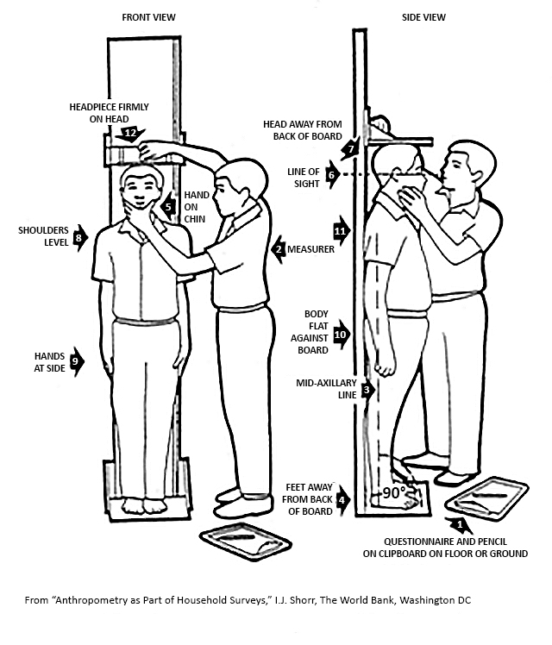

1. **Measurer:** Determine whether the woman’s heels should be against or away from the back of the height measuring board by observing her profile.
   * An imaginary line drawn from the tip of the woman’s shoulder to her heel (called the mid-axillary line; see Arrow 3) should be perpendicular (90°) to the base of the height board.
   * For all but extremely thin women, the woman’s buttocks should be against the back of the board and her head and heels should be slightly forward of the back of the board so the mid-axillary line is straight and perpendicular to the base of the height board (Arrow 4).
2. **Measurer:** Position the woman’s heels or knees together as they fall naturally. There are three possibilities; select whichever combination touches first when the woman stands on the measuring board:
   * Knees and heels together
   * Knees together but heels slightly apart
   * Heels together but knees slightly apart
3. **Measurer:** Position the woman’s head and upper body:
   * Ask the woman to look straight ahead.
   * Cup the woman’s chin between the thumb and index finger of your left hand and gradually close your hand (Arrow 5).
   * Position the woman’s head so that her line of sight is parallel to the ground (Arrow 6). *(Note that with most adults, the back of the head will not touch the back of the height board—there will be a space between the back of the person’s head and the back of the measuring board (Arrow 7).)*
   * After you have placed the woman’s head in the proper position, release your hand from her chin and ask her to hold her head still in the position in which you have just placed it.
   * Make sure the woman’s shoulders are level (Arrow 8), her hands are at her side (Arrow 9), and at least her buttocks touch the back of the measuring board. *(Note that with most adults, only the buttocks and perhaps the shoulder blades will touch the back of the measuring board (Arrows 10 and 11).)*
4. **Measurer:** Check the woman’s position (Arrows 3–11). Repeat any of the above steps as necessary until the woman’s position is correct.
5. **Measurer:** Lower the measuring board headpiece on top of her head, making sure to push through her hair (Arrow 12).
6. **Measurer:** Read the woman’s height out loud to the nearest 0.1 cm (one decimal place) to your assistant.
7. **Assistant:** Confirm the measurement by repeating it back to the measurer.
8. **Assistant:** Record the measurement to one decimal place in item 406 of the paper Module 4A form.
9. **Measurer:** Remove the measuring board headpiece from the woman’s head and help her step off the measuring board.
10. **Measurer:** Check the paper Module 4A form to make sure that the height of the woman has been completely and correctly recorded. Instruct the assistant to correct any errors.

## 6.4 Completing a woman’s measurements and next steps

After you have taken the woman’s height and weight measurements, thank the woman and enter the time (hour and minutes) that you completed the module for that woman in item 400N of the paper Module 4A form.

If there are additional women between the ages of 15 and 49 in the household, repeat the measurement procedure, beginning with the instructions in Section 6.1 above. If there are no additional women eligible for the module, continue to the next module.

**Test your knowledge:**

**How do you know the scale is accurate?**

* By measuring the same person twice?
* By measuring an object of known weight?
* By measuring an overweight and an underweight person?
* There is no way to measure the accuracy of the scale.

**Test your knowledge:**

**What should I do?**

You are preparing to take the height measurement of a female respondent.

She has her hair fashioned in an elaborate, high braided style that will not allow for an accurate measurement of her height.

You need to measure her height correctly, but she will not take out her braid.

# Anthropometry techniques for children

The detailed anthropometric techniques for weighing and measuring children are taken from UNICEF’s Multiple Index Cluster Survey Manual for Anthropometry[3] and adapted for the Feed the Future ZOI Surveys. Appendices C and D contain tips for troubleshooting issues that you might encounter when trying to obtain weight and height measurements.

It is extremely important to take measurements accurately. Classification of a child being well nourished or not will depend on the accuracy of your measurements. The following examples (Tables 2 and 3) illustrate the impact of a 1 cm measurement error on interpreting malnutrition using percentiles.

Table 2: Example of a Boy Age 15 Months Who is 8.0 kg

|  |  |  |  |  |
| --- | --- | --- | --- | --- |
| **Length** | **Percentile**  **Length/Age** | **Interpretation** | **Percentile**  **Weight/Length** | **Interpretation** |
| 71 cm | ~3rd percentile | Very stunted | 20th percentile | Not at risk |
| 72 cm | ~5th percentile | Stunted | 8th percentile | Low |
| 73 cm | ~8th percentile | Not at risk | 3rd percentile | Malnourished |

Table 3: Example of Girl Age 36 Months Who is 11.2 kg

|  |  |  |  |  |
| --- | --- | --- | --- | --- |
| **Length** | **Percentile**  **Height/Age** | **Interpretation** | **Percentile**  **Weight/Height** | **Interpretation** |
| 87 cm | ~5th percentile | Stunted | 12th percentile | Not at risk |
| 88 cm | ~8th percentile | Low | 8th percentile | Low |
| 89 cm | ~11th percentile | Not at risk | 5th percentile | Malnourished |

## 

## 7.1 Preparing to take measurements

**Complete the fields that identify the child on the paper Module 5A form**

As you prepare to weigh the first child in a household, take out a new data collection form—a paper version of Module 5A, *Children’s Anthropometry*. You will record all the information for the first child in the household in the “CHILD 1” column. If there are multiple children to weigh and measure, determine which child you will weigh and measure first and complete items 500M through 508 by following these steps:

1. Record the time (hours and minutes) that you begin the measurement process for the first child in item 500M.
2. Record the cluster number and household number in item 500B. You can find this information in the household identification section of the questionnaire cover sheet. You will only record this information once per household.
3. Record the child’s first name and line number in item 500D. You can find the child’s line number in Module 1, *Household Roster and Demographics*.This number is also pre-populated in item 500D in Module 5, *Children’s Nutrition*.

For each additional child under 6 years of age in the household, repeat steps 1 and 3, using the next available “CHILD” column. For example, enter the information for the second child to be measured in the “CHILD 2” column. If there are more than five children under 6 years of age in the household, use a second data collection form to record the information for the additional children after the fifth.

**Obtain informed consent**

Next, the measurer will confirm or obtain consent from the child’s caregiver to weigh and measure the child. If Module 4, *Children’s Nutrition*, has already been administered to the caregiver for the child who is to be weighed and measured, the caregiver has already provided consent for the child to participate in the survey, but confirm by asking, “Do you agree to allow your child, [CHILD’S NAME], to be weighed and measured?” If Module 4 has not yet been administered for the child, administer the informed consent procedure. If the caregiver refuses to let you take the child’s weight and height measurements, circle “9995” (REFUSED) for items 516 and 518 on the paper version of Module 5A. Also circle “6” (NOT MEASURED) for item 517, and enter the time that you completed the module for the child in item 519. Otherwise, if the caregiver gives consent, continue to prepare to take the measurements.

Be sure to get consent from the caregiver before weighing and measuring each additional child under 6 years of age in the household.

**Prepare to take the measurements**

Both the measurer and assistant should wash their hands and remove all jewelry, including rings, watches, and bracelets. The measurer and assistant should also be aware of any other sharp objects, such as pens, pencils, or sharp fingernails, while taking measurements.

The measurer should explain to the child’s caregiver that the child should wear only the lightest possible clothing while being weighed so that an accurate weight can be obtained. A wet diaper or shoes and jeans can weigh more than 0.5 kg. In addition, bulky clothing and other items, such as pony tails and braids, which might interfere with the height (length) measurement, should also be removed. Ask the caregiver to remove as much of the child’s clothing as possible, or ask permission from the caregiver to remove it yourself. Never remove any of the child’s clothing without first obtaining permission.

Babies should be weighed naked, but a blanket can be used to keep the baby warm. First weigh the caregiver who will hold the baby on the scale while he or she is holding the blanket. Then wrap the naked baby with the blanket and have the caregiver step onto the scale with the baby.

If it is too cold to undress a child or if the child resists being undressed and becomes agitated, weigh the clothed child, but make a note that the child could not be undressed to the minimum in the margins of the paper Module 5A form and communicate the circumstances to your field supervisor.

Be sure that that all equipment and other materials (for example, pens and paper recording forms) are ready before the child is undressed.

## 7.2 Measuring a child’s weight

You will weigh children less than 2 years of age while they are being held by their caregiver. You will do this using the scale’s 2-in-1 function, which requires that you first weigh the caregiver alone and then weigh the caregiver holding the infant or young child in his or her arms.

You will weigh children 2 years of age or older who are willing to stand still by themselves alone on the scale. If the child jumps on the scale or will not stand still, use the 2-in-1 weighing procedure used for children less than 2 years of age.

This section of the manual outlines the steps that you will follow to weigh children less than two years old and children two years or older.

### Weight17.2.1 Children less than 2 years of age

Follow these steps to weigh a child less than 2 years of age:

1. **Measurer or assistant:** Set up the scale, if it is not already set up. Place the scale on a hard, flat surface and make sure that it is stable.
2. **Measurer or assistant:** Switch on the scale, or if the scale is already switched on, press the “Start key,” while no weight is applied to the scale. Wait until “0.00” appears on the display.

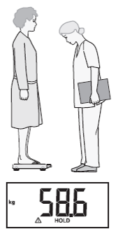

1. **Measurer:** Ask the caregiver to step onto the scale. The person’s weight will display. Note: The person being weighed must stand very still for the weight to appear on the display.
2. 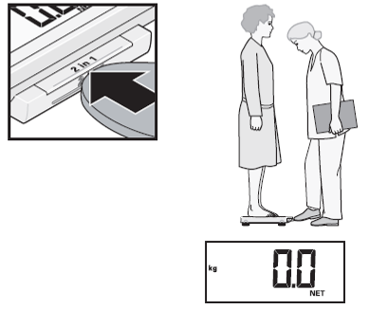**Measurer:** Press the “2-in-1” key while the caregiver is still standing on the scale. The scale will store the person’s weight, and “0.00” and the word “NET” will appear on the display.
3. **Measurer:** Ask the caregiver to take the child to be weighed onto the scale. The caregiver can step off the scale to get the child, in which case “-----” will appear on the display.
4. 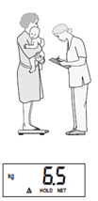**Measurer:** Ask the caregiver to hold the child while standing on the scale and to try not to move.
5. **Measurer:** Wait until the weight appears on the display and the message “HOLD" is no longer flashing.
6. **Measurer:** Read out the child’s weight to your assistant.
7. **Assistant:** Repeat the value back to the measurer.
8. **Assistant:** Record the value to two decimal places in item 518 of the paper Module 5A form after the measurer confirms that the value is correct.
9. **Measurer:** Check the paper Module 5A form to make sure that the weight of the child has been completely and correctly recorded. Instruct the assistant to correct any errors.
10. **Measurer:** Ask the caregiver to step off the scale with the child. The child’s weight will remain displayed.
11. **Measurer:** Ask the caregiver to step back onto the scale with the next child to be weighed, if there are multiple children under 2 years of age to weigh with the same caregiver.
12. **Measurer and assistant:** Repeat steps 5–12 for each additional child under 2 years of age in the household.

The caregiver’s weight will remain stored by the scale until the scale turns off or until another person’s weight is saved using the 2-in-1 function. You can therefore take weight measurements of other children while they are held by the same caregiver. Another child’s weight measurement is automatically taken as soon as the caregiver steps on the scale holding another child. You do not need to press the 2-in-1 function key or switch the scale off and on again between measurements.

It is important that the caregiver’s weight does not change between measurements (for example, by taking off a jacket). If the caregiver’s weight does change, you should weigh the caregiver alone again and save his or her new weight using the 2-in-1 function before measuring the weight of additional children. If you do not take any measurements for two minutes, the 2-in-1 function and the scale will automatically switch off, and you will need to start the weighing process from the beginning again.

### 7.2.2 Children 2 years of age or older

Follow these steps to weigh a child 2 years of age or older:

1. **Measurer or assistant:** Set up the scale, if it is not already set up. Place the scale on a hard, flat surface and make sure that it is stable.
2. **Measurer or assistant:** Explain in a sensitive, non-frightening way to the child that he or she will step on the scale alone and stand very still while you take his or her weight measurement.
3. **Measurer or assistant:** Switch on the scale, or if the scale is already switched on, press the “Start” key, while no weight is applied to the scale.
4. **Measurer:** Wait until “0.00” appears on the display.
5. **Measurer:** Ask the child to step on the scale and to stand in the middle of the scale, feet slightly apart.
6. **Measurer:** Ask the child to remain still until the weight appears on the display.
7. **Measurer:** Do not hold or support the child; this will interfere with the measurement. *(After the weight value is stable for about 3 seconds, the display is retained. This avoids the display jumping around if the child moves.)*
8. **Measurer:** Read the value on the scale display out loud to your assistant.
9. **Assistant:** Repeat the value back to the measurer.
10. **Assistant:** Record the value to two decimal places in item 518 of the paper Module 5A form after the measurer confirms that the value is correct.
11. **Measurer:** Check the paper Module 5A form to make sure that the weight of the child has been completely and correctly recorded. Instruct the assistant to correct any errors.

If the child jumps on the scale or will not stand still, use the 2-in-1 weighing procedure instead (see Section 7.2.1).

## 7.3 Measuring a child’s height

Children less than 2 years of age will be measured while they are lying down. The resulting measure is the child’s length. Children 2 years of age and older will be measured while they are standing. The resulting measure is the child’s height. The difference in recumbent (i.e., lying down) length versus standing height is 0.7cm, meaning that a child who is measured lying down will appear artificially taller than he or she would if measured standing up.

This section of the manual describes the steps that you will follow to obtain a child’s length or height.

### 7.3.1 Children less than 2 years of age

To measure the length of children less than 2 years of age, use the following steps:

*(Where indicated in the instructions, refer to the numbered arrows in Figure 2.)*

1. **Measurer or assistant:** Place the measuring board on a hard, flat surface, such as the ground, floor, or a steady table, if it is not already set up.
2. **Assistant:** Place the paper Module 5A form and pen on the surface next to the board (Arrow 1). Kneel with both knees behind the base of the board, if it is on the ground or floor (Arrow 2).
3. **Measurer:** Kneel on the child’s right side so that you can hold the footpiece with your right hand (Arrow 3).
4. **Measurer and assistant:** With the caregiver’s help, lay the child on the board by doing the following:

* **Assistant:** Support the back of the child’s head with your hands and gradually lower the child onto the board.
* **Measurer:** Support the child at the trunk of the body.

1. **Measurer or assistant:** Ask the caregiver to kneel or stand on the opposite side of the board facing the measurer to help keep the child calm.
2. **Assistant:** Position the child’s head:

* Cup your hands over the child’s ears (Arrow 4).
* With your arms comfortably straight (Arrow 5), place the child’s head against the base of the board so that the child is looking straight up. The child’s line of sight should be perpendicular to the ground (Arrow 6).
* Your head should be straight over the child’s head. Look directly into the child’s eyes.

1. **Measurer:** Position the child’s legs and feet:
   * Make sure the child is lying flat and in the center of the board (Arrow 7).
   * Place your left hand on the child’s shins (above the ankles) or on the knees (Arrow 8).
   * Press the child’s shins or knees firmly against the board.
2. **Measurer:** With your right hand, place the footpiece firmly against the child’s heels (Arrow 9).
3. **Measurer and assistant:** Check the child’s position (Arrows 4–9). Repeat any steps as necessary until the child’s position is correct.
4. **Measurer:** Read out loud the measurement to the nearest 0.1 cm (one decimal place).
5. **Assistant:** Confirm the measurement by repeating it back to the measurer.
6. **Measurer:** Remove the footpiece and release your left hand from the child’s shins or knees.
7. **Assistant:** On the paper Module 5A form, record the measurement to one decimal place in item 516, and circle “1” (LYING DOWN) in item 517 to indicate that child was measured while lying down.
8. **Measurer:** Check the paper Module 5A form to make sure that the length of the child has been completely and correctly recorded. Instruct the assistant to correct any errors.
9. **Measurer and assistant:** If the child’s length is ≥ 85 cm, re-measure the child while he or she is standing up.

Figure : Measuring a Child’s Length

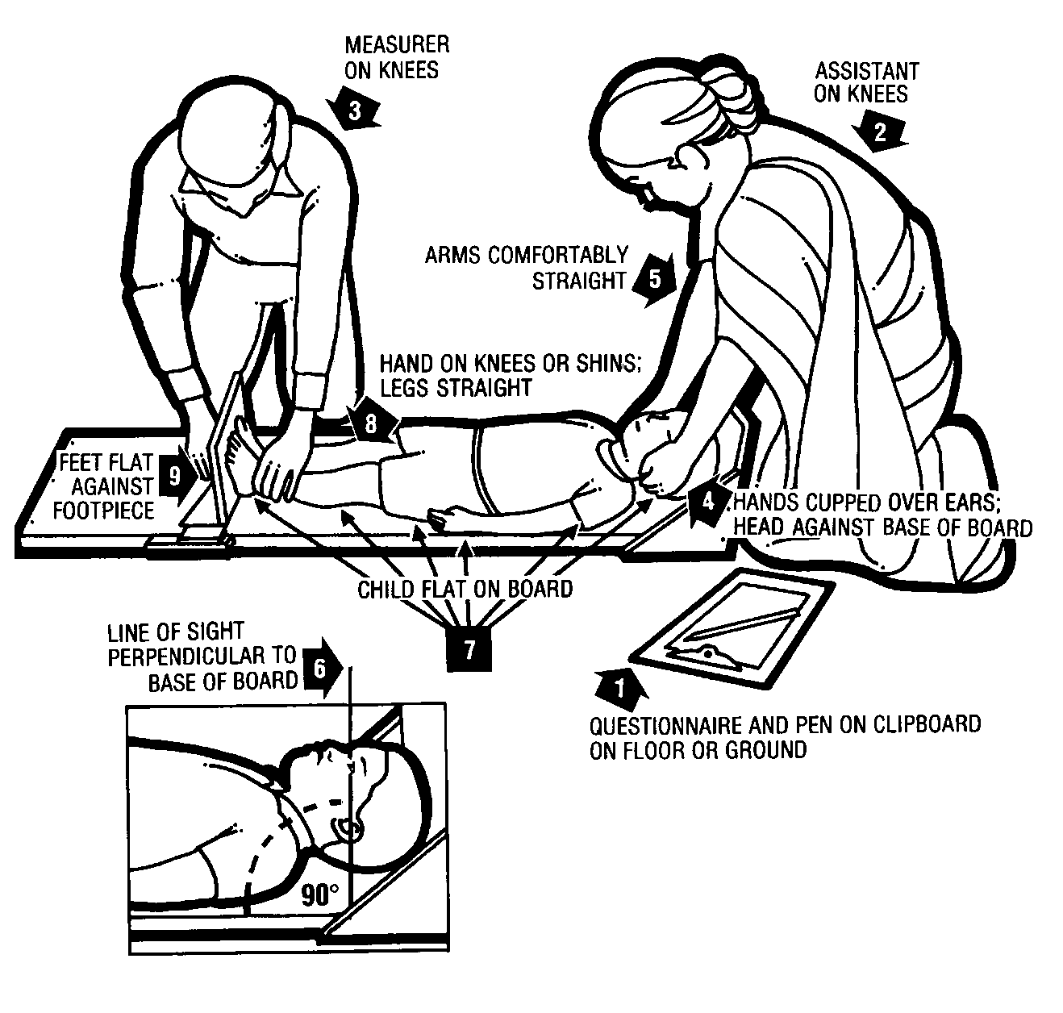

### 7.3.2 Children 2 years of age or older

To measure the height of children 2 years of age or older, use the following steps:

*(Where indicated in the instructions, refer to the numbered arrows in Figure 3.)*

1. **Measurer or assistant:** Set up the board, if it is not already set up.

* Place the measuring board on a hard, flat surface against a wall, table, tree, staircase, etc.
* Make sure the board is stable.
  + - Many walls and floors are not at perfect right angles; if necessary, place small rocks underneath the height board to stabilize it during the measurement.
    - If the only level surface available to place the board does not have a steady structure to lean it against, and there are no sturdy pieces of furniture that can be moved behind it, have an adult stand behind the board and provide the support so it does not tip over.

1. **Measurer or assistant:** Ask the caregiver to remove the child’s shoes and socks if they have not already been removed. Also ask the caregiver to unbraid any hair that will add to the child’s height or to take out any ponytails or other hairstyles that will not allow the child to stand with the back of his or her head flush against the measuring board.
2. **Measurer or assistant:** Ask the caregiver to walk the child to the board and to kneel in front of the child so that he or she can comfort the child during the measurement process.
3. **Assistant:** Place the paper Module 5A form and pen on the ground (Arrow 1). Kneel with both knees on the child’s right side (Arrow 2).
4. **Measurer:** Kneel on your right knee only, for maximum mobility, on the child’s left side (Arrow 3).
5. **Assistant:** Position the child’s feet and legs:

* Place the child’s feet flat and together in the center of and against the back of the base of the board.
* Place your right hand just above the child’s ankles on the shins (Arrow 4), place your left hand on the child’s knees (Arrow 5), and push against the board.
* Make sure the child’s legs are straight and the heels and calves are against the board (Arrows 6 and 7).
* Tell the measurer when you have completed positioning the feet and legs.

1. **Measurer:** Position the child’s head and upper body:

* Tell the child to look straight ahead at the caregiver if he or she is in front of the child.
* Make sure the child is looking straight ahead and his or her line of sight is level with the ground (Arrow 8).
* Place your open left hand on the child’s chin. Gradually close your hand around the chin (Arrow 9). Do not pinch the jaw. Do not cover the child’s mouth or ears.
* Make sure the child’s shoulders are level (Arrow 10), the hands are at the child’s side (Arrow 11), and the head, shoulder blades, and buttocks are against the board (Arrows 12, 13, and 14).

1. **Measurer and assistant:** Check the child’s position (Arrows 6–14). Repeat any steps as necessary until the child is correctly positioned.
2. **Measurer:** With your right hand, lower the headpiece on top of the child’s head. Make sure you push through the child’s hair (Arrow 15).
3. **Measurer:** Read the measurement out loud to the nearest 0.1 centimeter (one decimal place) to your assistant.
4. **Assistant:** Confirm the measurement by repeating it back to the measurer.
5. **Assistant:** On the paper Module 5A form, record the measurement to one decimal place in item 516, and circle “2” (STANDING UP) in item 517 to indicate that child was measured while standing.
6. **Measurer:** Remove the headpiece from the child’s head and remove your left hand from the child’s chin.
7. **Measurer:** Check the paper Module 5A form to make sure that the height of the child has been completely and correctly recorded. Instruct the assistant to correct any errors.
8. **Measurer and assistant:** If the child’s length is < 85 cm, re-measure the child while he or she is lying down.

Figure : Measuring a Child’s Height

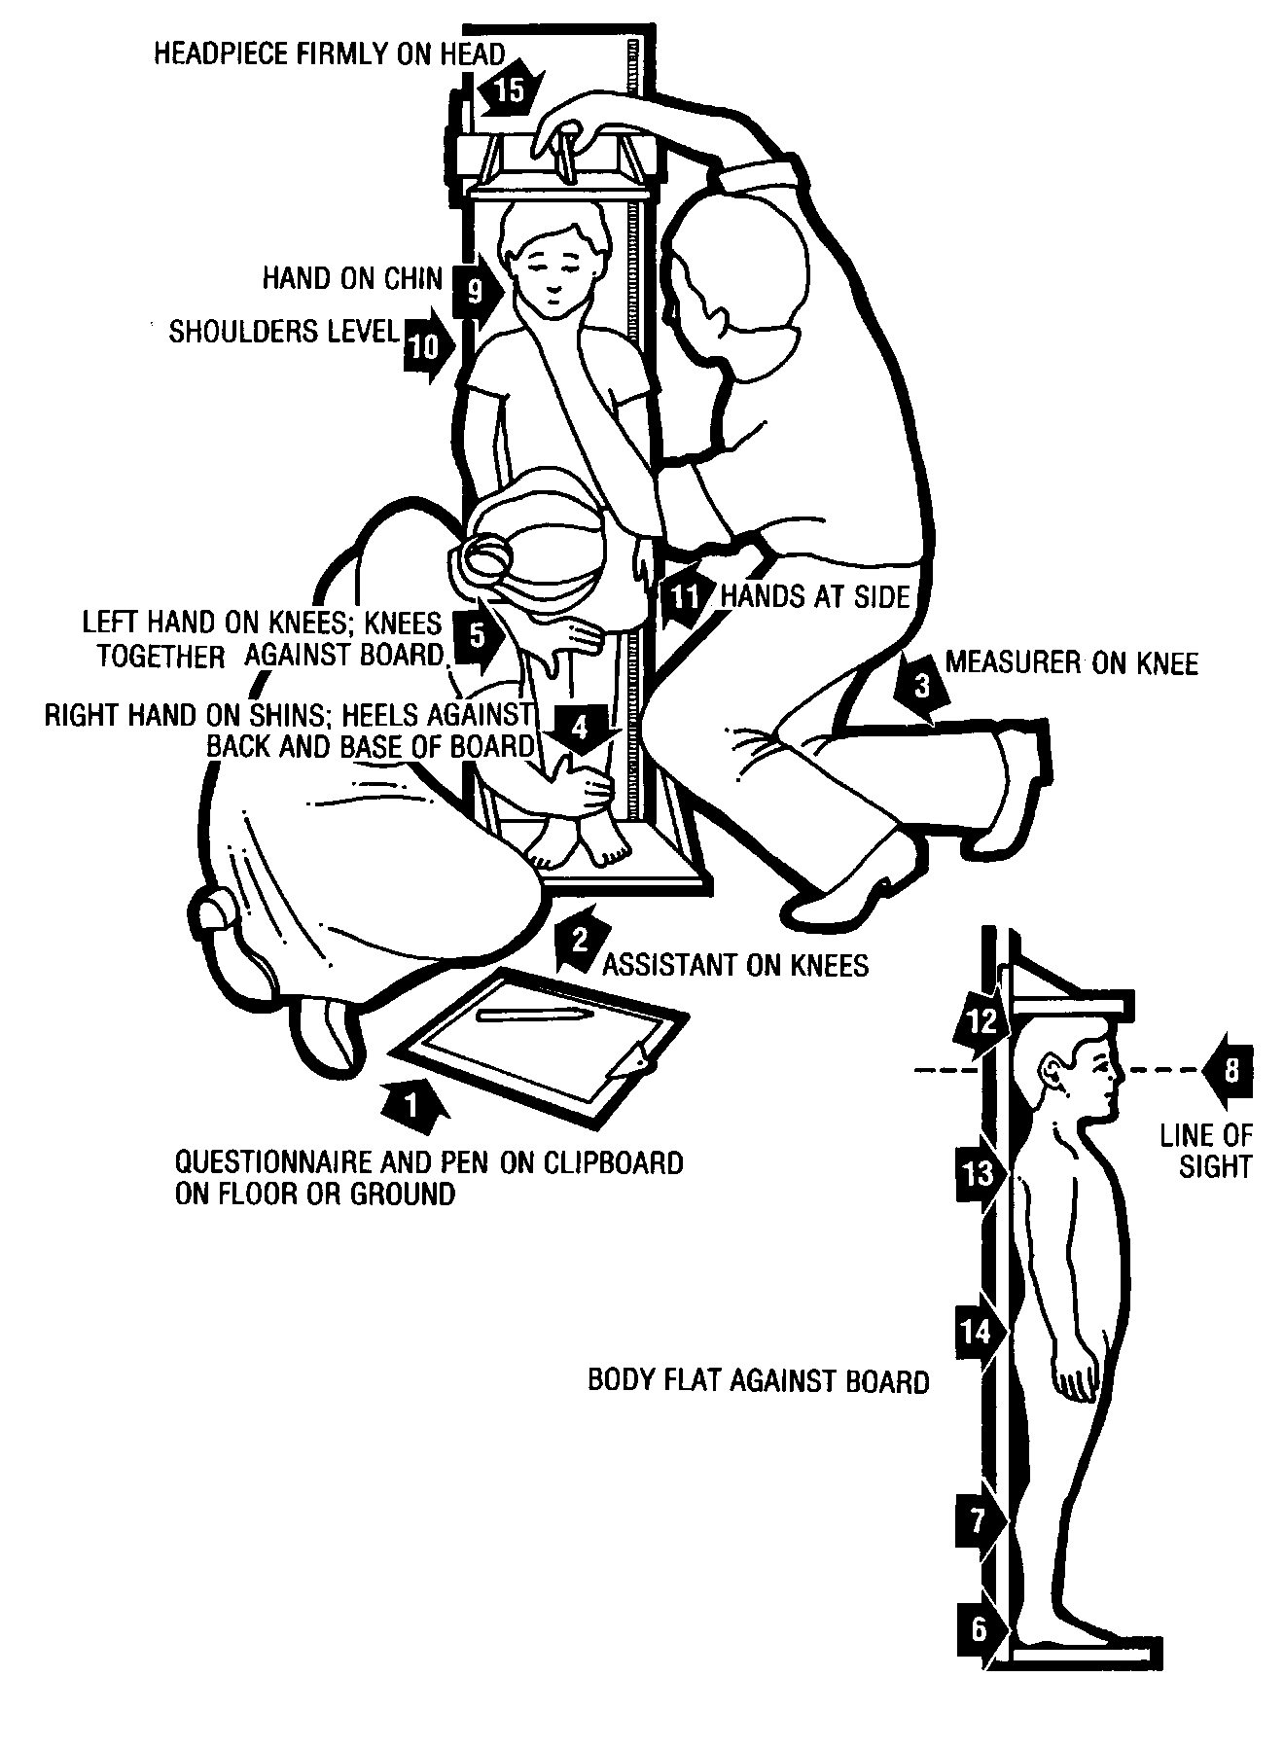

## 7.4 Completing a child’s measurements and next steps

After you have taken the child's height and weight measurements, enter the time (hour and minutes) that you completed the module for that child in item 519 of the paper Module 5A form.

If there are additional children less than 6 years of age in the household, repeat the measurement procedure, beginning with the instructions in Section 7.1. If there are no additional children eligible for the module, continue to the next module.

**Test your knowledge:**

**If you measured a 26-month-old to be 83 cm, what should you do?**

*(Select all that apply.)*

* If measured lying down, you do not need to do anything.
* If measured lying down, re-measure the child standing up.
* If measured standing up, re‑measure the child lying down.
* If measured standing up, you do not need to do anything.

**Test your knowledge:**

**What should you do?**

You are preparing to weigh a 30‑month‑old child.

As his caregiver tried to remove his shorts and t-shirt, the boy protested. He lay on the floor kicking and waving his arms while yelling and crying.

Other children in the household were watching. An infant also started to cry.

What should you do?

# Entering the anthropometry information in the tablet

After you finish weighing and measuring all the women and children in the household, you will enter the information that you recorded on the paper versions of modules 4A and 5A in interviewer B’s tablet.

**Note:** Complete all measurements in the household before entering the information from the paper version (Modules 4A and 5A) in the tablet.

# Reviewing anthropometric results in women ages 15–49

After you finish weighing and measuring each woman and enter the values in your tablet, your tablet will display her BMI. The BMI is an indication of whether an adult is underweight or overweight. (See Appendix F for a woman’s BMI chart.) There are lower and upper limits that are considered reasonable for most adults. You should check the measurements for errors if:

* The woman’s BMI is less than 13.0 or greater than 60.0.
* The woman’s weight is less than 30 kg or greater than 200 kg.
* The woman’s height is less than 130 cm or greater than 205 cm.

If the woman’s BMI, height, or weight is **outside these limits,** there is probably an error in the weight or height that was entered. Check your data entry for errors and correct the entry, or, if necessary, weigh and measure the woman again.

If the data fall **within these limits**, but the woman’s BMI is less than 18.5, then she is likely to be underweight, or if her BMI is greater than 24.9, then she is likely to be overweight. Glance at the woman to determine visually if her BMI is consistent with her appearance. If it is not, check the data you entered and, if necessary, weigh and measure her again.

# Practicing taking measurements

It is important to practice taking height and weight measurements before fieldwork begins so that you develop your skills. Anthropometry training will, therefore, include not only lectures and demonstrations but also the opportunity to practice measuring, reading, and recording the heights, lengths, and weights of women and children. This hands-on experience will allow trainers to provide you with feedback and correct any mistakes. Practice will help identify sources and types of errors, and you can then improve your methods and techniques through subsequent training and practice. Practice will also give you confidence.

The goals of the practice session are to ensure that all measurers and assistants understand and adhere to the measurement procedures and that the measurements are precise and accurate. Precise means that you can repeat your measurements with minimal variation, and accurate means that you can take measurements close to the “true” weight. Practice will minimize measurement variability within measurers and between measurers and help ensure that the measurements are comparable across field teams and across ZOI Surveys.

The training coordinators will choose a location for the practice session and make arrangements for you to travel to the location or for children and women to come to the training center on the designated day during the training.

The lead anthropometry trainer will assign you to work in pairs for the practice session. Each pair will take the measurements of at least four different children—two who are less than 2 years of age and two who are 2 years of age or older—and two different women. You will serve as the measurer for all six individuals, and your partner will serve as the assistant. You will then switch roles and weigh and measure all six individuals again. Each pair will weigh and measure the same children and women twice, so if there are 10 pairs, each individual will be weighed and measured 20 times.

The lead anthropometry trainer will weigh and measure each woman and child and record their measurements before the practice session begins. The trainer’s measurements will serve as the reference, or “true,” measurements against which the measurements recorded by all measurers will be compared.

## 10.1 Preparing for the practice session

The lead anthropometry trainer will:

* Assign you a partner. You and your partner will alternate being the measurer and assistant during the practice session.
* Assign a number to each woman and child who will be measured during the practice session.
* Place a scale and measuring board at each work station, allowing adequate room between stations to ensure that the measurers and assistants can work comfortably and that pairs cannot see or hear each other’s results.
* Ensure that all pairs have the materials that they need (for example, pens, paper recording forms, clipboard).

## 10.2 Practice session guidelines

* Pairs should be sure to follow the measurement procedures in this manual.
* Pairs can take the measurements on the children and women in any order (i.e., as soon as a person is free to weigh and measure, a pair can go directly to that person to take his or her measurements). Pairs can also move from station to station in a specified order when the trainer tells them to move.
* The measurer should ensure that the assistant records each person’s measurements in the correct place on the data collection form, using the number assigned to each person as the person’s line number.
* Pairs can re-weigh or re-measure any person as many times as they would like before submitting their completed data collection forms to the trainers.
* The trainers will observe all the measurers and assistants during the practice session and take notes on any errors in procedures. The trainers will review their notes with all the measurers and assistants during the debrief at the end of the practice session.

## 10.3 Analyzing the results

After all the women and children have been measured twice by all of the pairs, the lead anthropometry trainer will analyze the results of the practice session together with the trainees using the following steps:

1. All of the trainees will copy the measurements that they recorded on their data collection forms to the My Measure weight and height (length) columns on practice session analysis form (see Appendix E).
2. The trainer will read out loud his or her measurements for each person, and all of the trainees will record the results on their respective forms, in the Standard Measure weight and height (length) columns.
3. Each trainee will calculate the difference between My Measure and Standard Measure for each measurement and record the result on in the Difference columns, preceded by either a positive (+) or negative (-) sign. If the measurer’s measurement is larger than the trainer’s measurement, the sign is positive. If the measurer’s measurement is smaller than the trainer’s measurement, the sign is negative. If the measurer and trainer’s measurements are exactly the same, do not record a sign.
4. In the Size column, indicate the size of the difference between the trainee’s measure and the trainer’s measure with an “L” (large), “M” (medium), or “S” (small). See Table 4 for the definitions of the size categories for weights and heights/lengths.

Table 4: Large, Medium, and Small Differences for Weights and Heights (Lengths)

|  |  |  |
| --- | --- | --- |
| Difference | Weight (kg) | Height (Length) (cm) |
| Large | ≥ 0.30 | ≥ 1.0 |
| Medium | 0.15–0.25 | 0.6–0.9 |
| Small | 0.00–0.10 | 0.0–0.5 |

1. After recording all of the Difference and Size columns, count and record the total number of large, medium, and small weight and height (length) differences in the summary table at the bottom of the form.
2. Also count and record the total number of differences with a positive sign and the total number of differences with a negative sign—first for weights and then for heights (lengths)—in the summary table. (The magnitude of the difference does not matter.) For example, if there are four weights that have a positive sign and two weights that have a negative sign, record +2 in the Sign column for weight, and if there are five height (lengths) that have a negative sign and one that has no sign, record -5 in the Sign column for height (length).

## 10.4 Interpreting the results

The trainees will interpret the practice session results with the trainers’ help. The purpose is to detect differences between the trainees’ measurements and the trainer’s measurements, identify their possible causes, and correct them. To do this, trainees must take into account the size and sign (+ or -) of the differences, described as follows.

* **Size of the difference.** The larger the number of differences categorized as small, the greater the agreement between the measurer and trainer. Large differences generally indicate carelessness in the reading or recording, or serious problems in measurement technique. Medium differences usually indicate problems in measurement technique. If any large or medium differences are recorded, the measurer should repeat the measurements that resulted in the large or medium differences with the assistance of a trainer to identify and correct the cause of the differences.
* **Sign of the difference.** If the number recorded in the sign box is +4, +5, or +6, the measurer’s measurements are consistently larger than the trainer’s. For weight measurements, the most frequent causes of differences are not properly taring the scale if using the 2-in-1 function or reading the weight before it freezes on the display. For height (length) measurements, the most frequent causes of differences are improper positioning of the head or feet against the headpiece or footpiece, improper positioning of legs or upper body against the measuring board, or reading a measurement at an angle and not facing the reading point of the measuring board.

If the number in the sign box is -4, -5, or -6, the measurer’s measurements are consistently smaller than the trainer’s. For both weight and height (length) measurements, the most frequent causes for differences are similar to those described in the previous paragraph for consistently large measurements. For height (length) measurements, one additional cause is that the child’s legs might be flexed during the measurement.

* **Comparison between measurers.** The analysis forms can be used to make comparisons between measurers. If the frequency, magnitude, and sign of the differences are similar for multiple measurers, this can suggest that they may have common problems. If the differences across multiple measurers are primarily related one or two particular children, the issues may be related to the children moving too much while being measured. All the measurers should repeat the measurements of these children with oversight from the trainer to identify and correct any problems.

Table 5 contains the practice session summary results for four measurers (A, B, C, and D).

Table 5: Summary of Differences for Weights and Heights (Lengths) for Four Measurers

|  |  |  |  |  |
| --- | --- | --- | --- | --- |
| **Measurer** | | | | |
| Difference | **A** | **B** | **C** | **D** |
| Large | 1 | 2 | 0 | 0 |
| Medium | 4 | 0 | 2 | 8 |
| Small | 5 | 8 | 8 | 2 |
| Sign | +2 | -5 | +6 | -6 |

The results can be interpreted as follows:

* **Measurer A:** Careless measurement (reading or recording) and problems with the measurement technique, but the sign result indicates that the measurer obtains measurements both larger and smaller than the trainer.
* **Measurer B:** Careless measurement and no evident problems with the measurement technique, but the sign result indicates that the measurer consistently obtains measurements smaller than the trainer.
* **Measurer C:** Generally well done (1 to 2 medium differences may be allowed), but the sign result indicates that the measurer consistently obtains measurements larger than the trainer.
* **Measurer D:** Problems are evident with the measurement technique, and the sign result indicates that the measurer consistently obtains measurements smaller than the trainer.

# Appendix A: Expected values for height (length) and weight for children ages 0–59 months[4]

|  |  |  |  |  |  |  |  |  |
| --- | --- | --- | --- | --- | --- | --- | --- | --- |
| **Age in Months** | **Length (centimeters)** | | | | **Weight (kilograms)** | | | |
| **Male** | | **Female** | | **Male** | | **Female** | |
| **Minimum** | **Maximum** | **Minimum** | **Maximum** | **Minimum** | **Maximum** | **Minimum** | **Maximum** |
| 0–2 | 36.0 | 74.0 | 36.0 | 72.0 | 0.5 | 10.0 | 0.5 | 9.0 |
| 3–5 | 45.0 | 83.0 | 44.0 | 80.0 | 1.0 | 13.0 | 1.0 | 12.0 |
| 6–8 | 51.0 | 87.0 | 50.0 | 86.0 | 2.0 | 15.0 | 2.0 | 14.0 |
| 9–11 | 56.0 | 91.0 | 54.0 | 90.0 | 3.0 | 16.5 | 2.5 | 15.5 |
| 12–14 | 59.0 | 96.0 | 57.0 | 95.0 | 4.0 | 17.5 | 3.0 | 16.5 |
| 15–17 | 62.0 | 100.0 | 60.0 | 99.0 | 4.0 | 18.5 | 3.5 | 17.5 |
| 18–20 | 64.0 | 104.0 | 62.0 | 102.0 | 4.0 | 19.5 | 3.5 | 18.5 |
| 21–23 | 65.0 | 107.0 | 64.0 | 106.0 | 4.5 | 20.5 | 4.0 | 19.5 |
| 24–26 | 67.0 | 108.0 | 66.0 | 107.0 | 4.5 | 23.0 | 4.5 | 21.5 |
| 27–29 | 68.0 | 112.0 | 68.0 | 111.0 | 5.0 | 24.0 | 5.0 | 23.0 |
| 30–32 | 70.0 | 115.0 | 69.0 | 114.0 | 5.0 | 24.5 | 5.0 | 24.5 |
| 33–35 | 71.0 | 118.0 | 71.0 | 117.0 | 5.0 | 25.5 | 5.0 | 25.5 |
| 36–38 | 73.0 | 121.0 | 72.0 | 120.0 | 5.0 | 26.0 | 5.0 | 27.0 |
| 39–41 | 74.0 | 124.0 | 74.0 | 122.0 | 5.0 | 27.0 | 5.0 | 28.0 |
| 42–44 | 75.0 | 127.0 | 75.0 | 124.0 | 5.0 | 28.0 | 5.5 | 29.0 |
| 45–47 | 77.0 | 129.9 | 77.0 | 126.0 | 5.0 | 29.0 | 5.5 | 30.0 |
| 48–50 | 78.0 | 132.0 | 78.0 | 129.0 | 5.0 | 30.0 | 5.5 | 31.0 |
| 51–53 | 79.0 | 134.0 | 79.0 | 131.0 | 5.0 | 31.0 | 5.5 | 32.0 |
| 54–56 | 80.0 | 136.0 | 81.0 | 133.0 | 5.5 | 32.0 | 6.0 | 33.0 |
| 57–60 | 82.0 | 139.0 | 81.0 | 136.0 | 5.5 | 33.0 | 6.0 | 34.5 |

# Appendix B: Scale standardization test[5]

The purpose of this simplified scale standardization test is to assess whether the scale is weighing accurately. The following procedure will test the scale at the low end of its capacity and at the approximate middle of the scale’s capacity. It has been customized for the seca model 874 U scale, but it can be adapted for other models.

1. Switch the scale on and wait for the display to read “0.00” kg.
2. Place a 10 kg weight on the center of the scale.
3. Wait for the scale to freeze the weight on the display. The numbers will stop moving when the weight is held in the digital display panel using the “Auto-Hold” function of the scale
4. Record the weight on the Scale Standardization Test Form.
5. Remove the weight from the scale.
6. Wait for the scale to reset to “0.00” kg.
7. Ask an adult to stand on the scale.
8. Record the weight of the adult.
9. While the adult is still on the scale, press the 2-in-1 mother/baby function button on the scale; the digital display should now read “0.00.”
10. While the adult is still on the scale, place the 10 kg weight on the scale.
11. After the scale freezes the weight on the display, record the weight of the 10 kg weight on the Scale Standardization Test Form.
12. Ask the adult to step off the scale.
13. Repeat steps 2–12 two more times and record the results on the Scale Standardization Test Form.

**Acceptable Weight Readings**

The acceptable range of weights for the seca model 874 scale is + 0.25% of the displayed weight.

Because the seca model 874 scale reads in 0.05 kg increments, the only value that falls in the acceptable range of weights for the 10-kg weight itself is 10.00 kg. (Both 9.95 kg and 10.05 kg fall outside of the acceptable range.)

The acceptable range of weights for the 10 kg weight when placed on the scale with a person on the scale depends on the weight of the person. The range must be calculated using the TOTAL weight on the scale. For example, for a person who weighs 75 kg, the acceptable range of weights for the 10 kg weight is 9.80–10.20 kg.

**Summary**

* The acceptable weight range for a 10 kg weight alone on the scale contains only one value: 10.00 kg.
* The acceptable weight range for a 10 kg weight with a person on the scale depends on the weight of the person and is calculated as follows:
* (Weight of person in kg) + 10 kg = Total kg
* (Total kg) * 0.0025 = ± factor (rounded to nearest 0.05 kg) added to and subtracted from 10 kg
* The acceptable weight range for the 10 kg weight measured with a person on the scale is always greater than the acceptable range for the 10 kg weight measured alone.

Table B1: Scale Standardization Test Form

|  |  |  |  |  |  |  |  |
| --- | --- | --- | --- | --- | --- | --- | --- |
| **(1)** | **(2)** | **(3)** | **(4)** | **(5)** | **(6)** | **(7)** | **(8)** |
| **S.No.** | **Date** | **Weight of 10 kg** | **Acceptable  (10 kg)** | **Person + 10 kg Weight  (2-in-1 feature)** | **Col(5)*0.0025** | **Col(6) +/- 10 kg (round up to 0.05 kg)** | **Acceptable  (9.80–10.20 kg)** |
|  |  |  |  |  |  |  |  |
|  |  |  |  |  |  |  |  |
|  |  |  |  |  |  |  |  |
|  |  |  |  |  |  |  |  |
|  |  |  |  |  |  |  |  |
|  |  |  |  |  |  |  |  |
|  |  |  |  |  |  |  |  |
|  |  |  |  |  |  |  |  |
|  |  |  |  |  |  |  |  |
|  |  |  |  |  |  |  |  |

**Simplified Scale Standardization Test**

The purpose of this test is to assess whether the scale is weighing accurately.

* Weigh known weights 3, 5, 10, and 20 kg.
* Turn the scale on and wait until “0.00” appears on the display.
* Place the first weight on the scale.
* Record the weight that appears on the display.
* Remove the weight and wait
* Check tared weighing by weighing a 20 kg weight, taring the scale using the 2-in-1 button, and then adding a 3 kg weight. The weight of the 3 kg weight should appear on the display.
* If the weights displayed are not accurate, notify the field supervisor and determine whether the scale needs to be replaced.

# Appendix C: Troubleshooting issues with the seca scale

Table C1: Troubleshooting Errors with the Scale

| **Error** | **Solution** |
| --- | --- |
| Scale not calibrated | Test every morning.  Reset after every measurement. |
| Woman or child wearing heavy clothing or amulets | Remove in private or make allowances for clothing and amulets by subtracting their weight equivalent from the woman’s or child’s weight (for example, 100 grams of clothes for underwear). |
| No weight is displayed when there is a load on the scale | * Ask the adult to step off the scale and step gently on the weighing platform. * Check to see if the switch is in the “ON” position. * Check the batteries. |
| The scale keeps switching on while being transported | The vibration switch has been activated. Turn off the scale by switching the “ON-OFF” switch to the “OFF” position. |
| The scale displays a weight after being transported or after new batteries are installed | Wait until the scale switches off automatically after 2 to 3 minutes, and then switch it back on. |
| “0.00” does not appear before weighing |
| “----” appears instead of “0.00” before weighing |
| One segment of the display is illuminated constantly or not at all | There is a problem with that segment of the display. Inform your field supervisor and obtain a replacement scale. |
| The display shows a battery with split shading | The batteries are running low. Replace the batteries within a few days. |
| “..batt” appears in the display | The batteries are empty. Replace the batteries. |
| “Stop” appears in the display | The maximum load capacity of the scale (150 kg) has been exceeded. |
| The display flashes | Take the load off the scale and wait until “0.00” appears on the display. Then take the weight measurement again. |
| “temp” appears in the display | The ambient temperature of the scale is too high or too low. Place the scale in an ambient temperature between +10°C and +40°C. Wait 15 minutes for the scale to adapt to the temperature and then take the weight measurement again. |
| “E” and a number appear in the display | Wait until the scale switches off automatically after 2 to 3 minutes, and then switch it back on, ensuring that there is no load on the scale. If there is still an error, inform your field supervisor and obtain a replacement scale. |

# Appendix D: Troubleshooting issues while height measurements

Table D1: Troubleshooting while Taking Height Measurements

|  |  |
| --- | --- |
| **Problem** | **Solution** |
| Incorrect method for age or height (length) | Measure length (lying down) when child is less than 2 years of age or less than 85 cm. If a child is 2 years of age or older but less than 85 cm, measure lying down. Otherwise, measure height (standing up). |
| Woman or child wearing footwear or head gear | Remove in privacy, if necessary. |
| Head not in correct plane (chin too high or too close to body) | Get child to hold head straight by talking to him, crouching down to his level, and looking into his eyes. This will encourage the child to look at you, so position yourself to get his head at a right angle. |
| Child not straight along board, knees bent, feet pointing down when lying down | Correct technique with practice and regular retraining. If needed, involve a third person; ask the mother or caregiver to stand or kneel between you and your assistant to hold the child’s arms and talk to calm him. |
| Sliding board not firmly against heels (length) or head (height) | Settle the child. Ensure that adequate pressure is applied. If measuring a child standing up, move head board to compress hair and ensure that head touches board. If measuring a child lying down, move the sliding board to firmly touch the bottom of the feet. |
| Child not straight along board (feet apart or knees bent) | Do not take measurements while the child is struggling. Ask the mother or caregiver to talk to the child while you and your assistant get the child into the correct position. |

# Appendix E: Anthropometry practice session analysis form

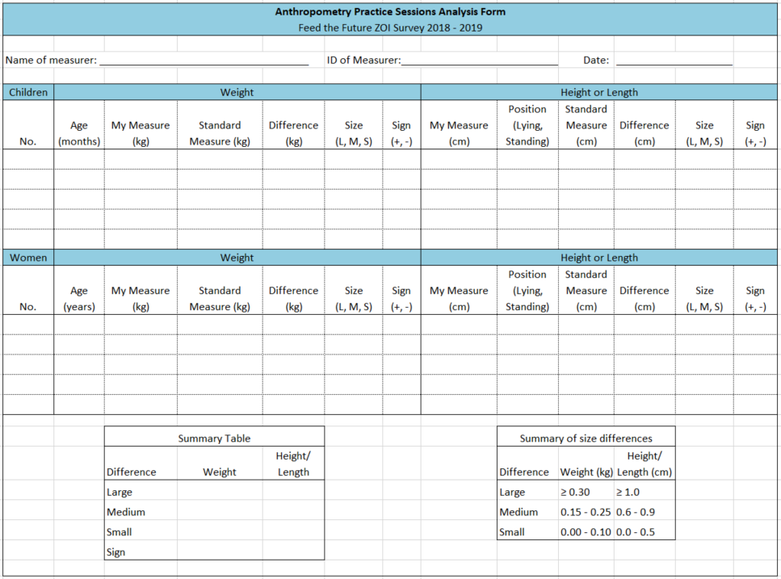

# Appendix F: Women’s BMI chart

*Values in the shaded regions are considered extreme BMI values for women (<16 and >35 kg/m2).*

| **Cms** | **130** | **135** | **140** | **145** | **150** | **155** | **160** | **165** | **170** | **175** | **180** | **185** | **190** | **195** | **200** | **205** |
| --- | --- | --- | --- | --- | --- | --- | --- | --- | --- | --- | --- | --- | --- | --- | --- | --- |
| **Kgs** |  |  |  |  |  |  |  |  |  |  |  |  |  |  |  |  |
| **39** | 23.1 | 21.4 | 19.9 | 18.5 | 17.3 | 16.2 | 15.2 | 14.3 | 13.5 | 12.7 | 12.0 | 11.4 | 10.8 | 10.3 | 9.8 | 9.3 |
| **42** | 24.9 | 23.0 | 21.4 | 20.0 | 18.7 | 17.5 | 16.4 | 15.4 | 14.5 | 13.7 | 13.0 | 12.3 | 11.6 | 11.0 | 10.5 | 10.0 |
| **45** | 26.6 | 24.7 | 23.0 | 21.4 | 20.0 | 18.7 | 17.6 | 16.5 | 15.6 | 14.7 | 13.9 | 13.1 | 12.5 | 11.8 | 11.3 | 10.7 |
| **48** | 28.4 | 26.3 | 24.5 | 22.8 | 21.3 | 20.0 | 18.8 | 17.6 | 16.6 | 15.7 | 14.8 | 14.0 | 13.3 | 12.6 | 12.0 | 11.4 |
| **51** | 30.2 | 28.0 | 26.0 | 24.3 | 22.7 | 21.2 | 19.9 | 18.7 | 17.6 | 16.7 | 15.7 | 14.9 | 14.1 | 13.4 | 12.8 | 12.1 |
| **54** | 32.0 | 29.6 | 27.6 | 25.7 | 24.0 | 22.5 | 21.1 | 19.8 | 18.7 | 17.6 | 16.7 | 15.8 | 15.0 | 14.2 | 13.5 | 12.8 |
| **57** | 33.7 | 31.3 | 29.1 | 27.1 | 25.3 | 23.7 | 22.3 | 20.9 | 19.7 | 18.6 | 17.6 | 16.7 | 15.8 | 15.0 | 14.3 | 13.6 |
| **60** | 35.5 | 32.9 | 30.6 | 28.5 | 26.7 | 25.0 | 23.4 | 22.0 | 20.8 | 19.6 | 18.5 | 17.5 | 16.6 | 15.8 | 15.0 | 14.3 |
| **63** | 37.3 | 34.6 | 32.1 | 30.0 | 28.0 | 26.2 | 24.6 | 23.1 | 21.8 | 20.6 | 19.4 | 18.4 | 17.5 | 16.6 | 15.8 | 15.0 |
| **66** | 39.1 | 36.2 | 33.7 | 31.4 | 29.3 | 27.5 | 25.8 | 24.2 | 22.8 | 21.6 | 20.4 | 19.3 | 18.3 | 17.4 | 16.5 | 15.7 |
| **69** | 40.8 | 37.9 | 35.2 | 32.8 | 30.7 | 28.7 | 27.0 | 25.3 | 23.9 | 22.5 | 21.3 | 20.2 | 19.1 | 18.1 | 17.3 | 16.4 |
| **72** | 42.6 | 39.5 | 36.7 | 34.2 | 32.0 | 30.0 | 28.1 | 26.4 | 24.9 | 23.5 | 22.2 | 21.0 | 19.9 | 18.9 | 18.0 | 17.1 |
| **75** | 44.4 | 41.2 | 38.3 | 35.7 | 33.3 | 31.2 | 29.3 | 27.5 | 26.0 | 24.5 | 23.1 | 21.9 | 20.8 | 19.7 | 18.8 | 17.8 |
| **78** | 46.2 | 42.8 | 39.8 | 37.1 | 34.7 | 32.5 | 30.5 | 28.7 | 27.0 | 25.5 | 24.1 | 22.8 | 21.6 | 20.5 | 19.5 | 18.6 |
| **81** | 47.9 | 44.4 | 41.3 | 38.5 | 36.0 | 33.7 | 31.6 | 29.8 | 28.0 | 26.4 | 25.0 | 23.7 | 22.4 | 21.3 | 20.3 | 19.3 |
| **84** | 49.7 | 46.1 | 42.9 | 40.0 | 37.3 | 35.0 | 32.8 | 30.9 | 29.1 | 27.4 | 25.9 | 24.5 | 23.3 | 22.1 | 21.0 | 20.0 |
| **87** | 51.5 | 47.7 | 44.4 | 41.4 | 38.7 | 36.2 | 34.0 | 32.0 | 30.1 | 28.4 | 26.9 | 25.4 | 24.1 | 22.9 | 21.8 | 20.7 |
| **90** | 53.3 | 49.4 | 45.9 | 42.8 | 40.0 | 37.5 | 35.2 | 33.1 | 31.1 | 29.4 | 27.8 | 26.3 | 24.9 | 23.7 | 22.5 | 21.4 |
| **93** | 55.0 | 51.0 | 47.4 | 44.2 | 41.3 | 38.7 | 36.3 | 34.2 | 32.2 | 30.4 | 28.7 | 27.2 | 25.8 | 24.5 | 23.3 | 22.1 |
| **96** | 56.8 | 52.7 | 49.0 | 45.7 | 42.7 | 40.0 | 37.5 | 35.3 | 33.2 | 31.3 | 29.6 | 28.0 | 26.6 | 25.2 | 24.0 | 22.8 |
| **99** | 58.6 | 54.3 | 50.5 | 47.1 | 44.0 | 41.2 | 38.7 | 36.4 | 34.3 | 32.3 | 30.6 | 28.9 | 27.4 | 26.0 | 24.8 | 23.6 |
| **102** | 60.4 | 56.0 | 52.0 | 48.5 | 45.3 | 42.5 | 39.8 | 37.5 | 35.3 | 33.3 | 31.5 | 29.8 | 28.3 | 26.8 | 25.5 | 24.3 |
| **105** | 62.1 | 57.6 | 53.6 | 49.9 | 46.7 | 43.7 | 41.0 | 38.6 | 36.3 | 34.3 | 32.4 | 30.7 | 29.1 | 27.6 | 26.3 | 25.0 |
| **108** | 63.9 | 59.3 | 55.1 | 51.4 | 48.0 | 45.0 | 42.2 | 39.7 | 37.4 | 35.3 | 33.3 | 31.6 | 29.9 | 28.4 | 27.0 | 25.7 |
| **111** | 65.7 | 60.9 | 56.6 | 52.8 | 49.3 | 46.2 | 43.4 | 40.8 | 38.4 | 36.2 | 34.3 | 32.4 | 30.7 | 29.2 | 27.8 | 26.4 |
| **114** | 67.5 | 62.6 | 58.2 | 54.2 | 50.7 | 47.5 | 44.5 | 41.9 | 39.4 | 37.2 | 35.2 | 33.3 | 31.6 | 30.0 | 28.5 | 27.1 |
| **117** | 69.2 | 64.2 | 59.7 | 55.6 | 52.0 | 48.7 | 45.7 | 43.0 | 40.5 | 38.2 | 36.1 | 34.2 | 32.4 | 30.8 | 29.3 | 27.8 |
| **120** | 71.0 | 65.8 | 61.2 | 57.1 | 53.3 | 49.9 | 46.9 | 44.1 | 41.5 | 39.2 | 37.0 | 35.1 | 33.2 | 31.6 | 30.0 | 28.6 |
| **123** | 72.8 | 67.5 | 62.8 | 58.5 | 54.7 | 51.2 | 48.0 | 45.2 | 42.6 | 40.2 | 38.0 | 35.9 | 34.1 | 32.3 | 30.8 | 29.3 |
| **126** | 74.6 | 69.1 | 64.3 | 59.9 | 56.0 | 52.4 | 49.2 | 46.3 | 43.6 | 41.1 | 38.9 | 36.8 | 34.9 | 33.1 | 31.5 | 30.0 |

1. The UNICEF Multiple Indicator Cluster Survey (MICS) Manual for Anthropometry draws heavily on resources developed by the World Health Organization, Action Contre la Faim Canada, and the Food and Nutrition Technical Assistance Project. The illustrations and summary procedures for measuring length or height are adapted from *How to Weigh and Measure Children: Assessing the Nutritional Status of Young Children in Household Surveys*, Annex I, Summary Procedures prepared by the United Nations Department of Technical Co-operation, Development and Statistical Office (New York: 1986). The UNICEF MICS Manual for Anthropometry was downloaded from http://www.childinfo.org/mics5_collection.html on 31 July 2014.
2. ICF International. 2012. MEASURE DHS Biomarker Field Manual. Calverton, Maryland, USA: ICF International.
3. The UNICEF Multiple Indicator Cluster Surveys (MICS) Manual for Anthropometry draws heavily on resources developed by the World Health Organization, Action Contre la Faim Canada, and the Food and Nutrition Technical Assistance Project The illustrations and summary procedures for measuring length or height are adapted from *How to Weigh and Measure Children: Assessing the Nutritional Status of Young Children in Household Surveys*, Annex I, Summary Procedures prepared by the United Nations Department of Technical Co-operation, Development and Statistical Office (New York: 1986). The UNICEF MICS Manual for Anthropometry was downloaded from http://www.childinfo.org/mics5_collection.html on 31 July 2014.
4. Taken from the UNICEF Multiple Indicator Cluster Surveys Manual for Anthropometry, downloaded from http://www.childinfo.org/mics5_collection.html on 31 July 2014.
5. Adapted from Annex II of *Anthropometry Procedures for the Food for Peace Population-Based Household Survey*, which was developed by Irwin J. Shorr and approved through personal communications with scale technicians at seca.